You need a website

Before you start. You need to have access to your coastmountaincollege.ca email.

This is the only email you can sign up with and your username and password will be sent there so you need to be able to check that email. Many students know their college email address, but they have never checked it before.

Here is a link to the information about how to access your college email from the CMTN website:
https://www.coastmountaincollege.ca/student-services/campus-services/it-services/o365-outlook-webmail

If you have been able to open and read your coast mountain college email you are ready to get your site set up:

- Head to www.openedtech.ca
This is what you should see. Choose the link that says sign up.



2. You will come to a page that looks like this:

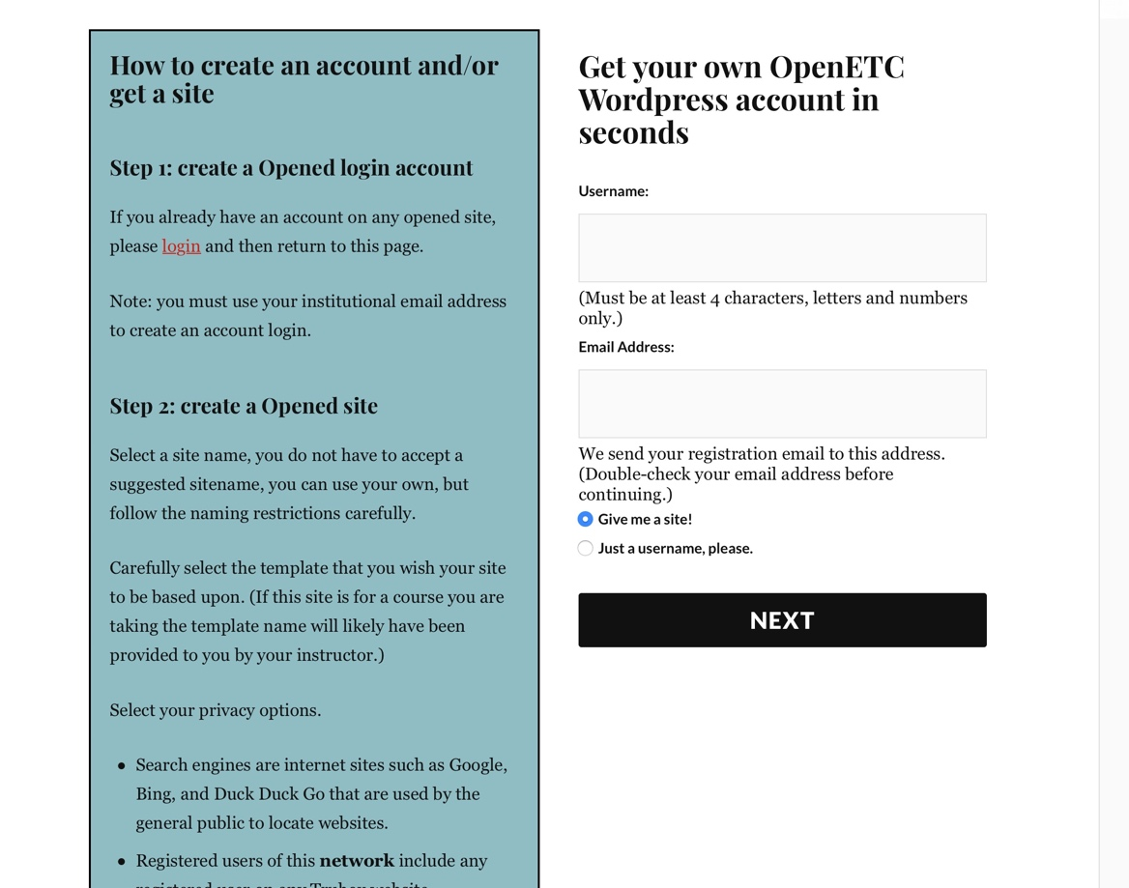

Your username is the username you want associated with this account. You make up your own. It needs to be at least four character using letters and numbers only.
This is the name you will use to log into your site. It is not readily visible to other users but you need to hold onto it so you can log in so keep it handy.

The second box is asking for your coast mountain college email.

Make sure the checkbox for Give me a site! is checked.

3. You will now come to a page that asks you for a site domain (an address for your site) and a site title.
When you choose your site domain you want it to be something that conveys the point of the site. It can be your name, it can be related to the course or the business plan you will use, ideally a combination of both. The site name will be (the site name you choose).opened.ca. Please don’t just go off the rails and call it something like ilovehonda or wolfprincess or something you may have associated with when you were in junior high school. It should be somewhat professional, related to the work we are doing and represent you.

The site title will be what shows up as the heading of your website in the site. I recommend it be business plan or your name’s business plan. You can review the site templates if you wish but the basic one is fine because once you are set up you can change the theme and look of your site. I don’t think it is necessary for search engines to index the site as the example shows below but you can if you like.

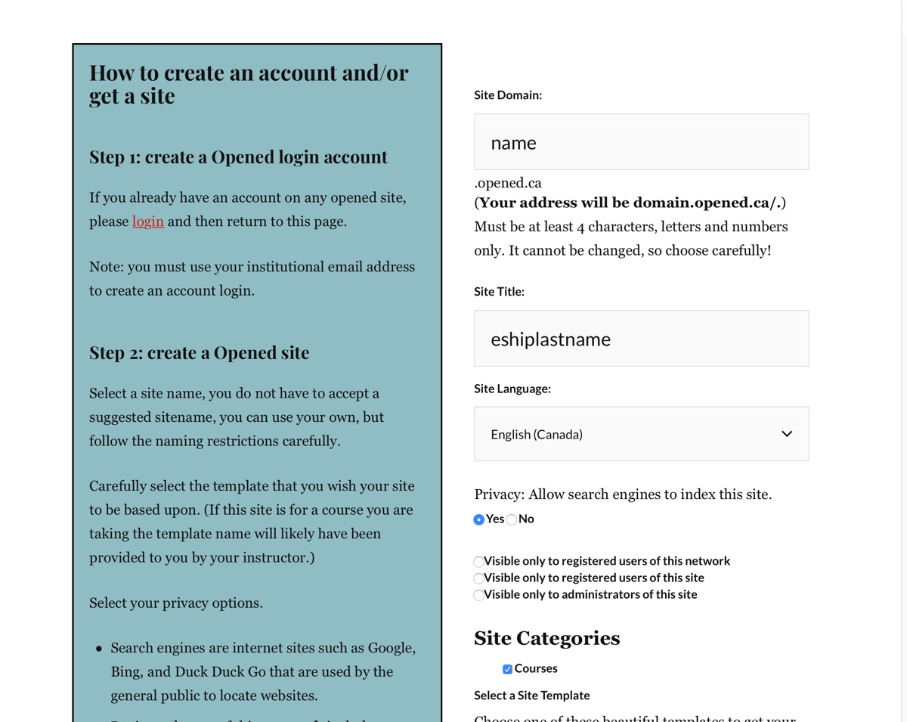

4. This will be the last message you see for setting up your site.
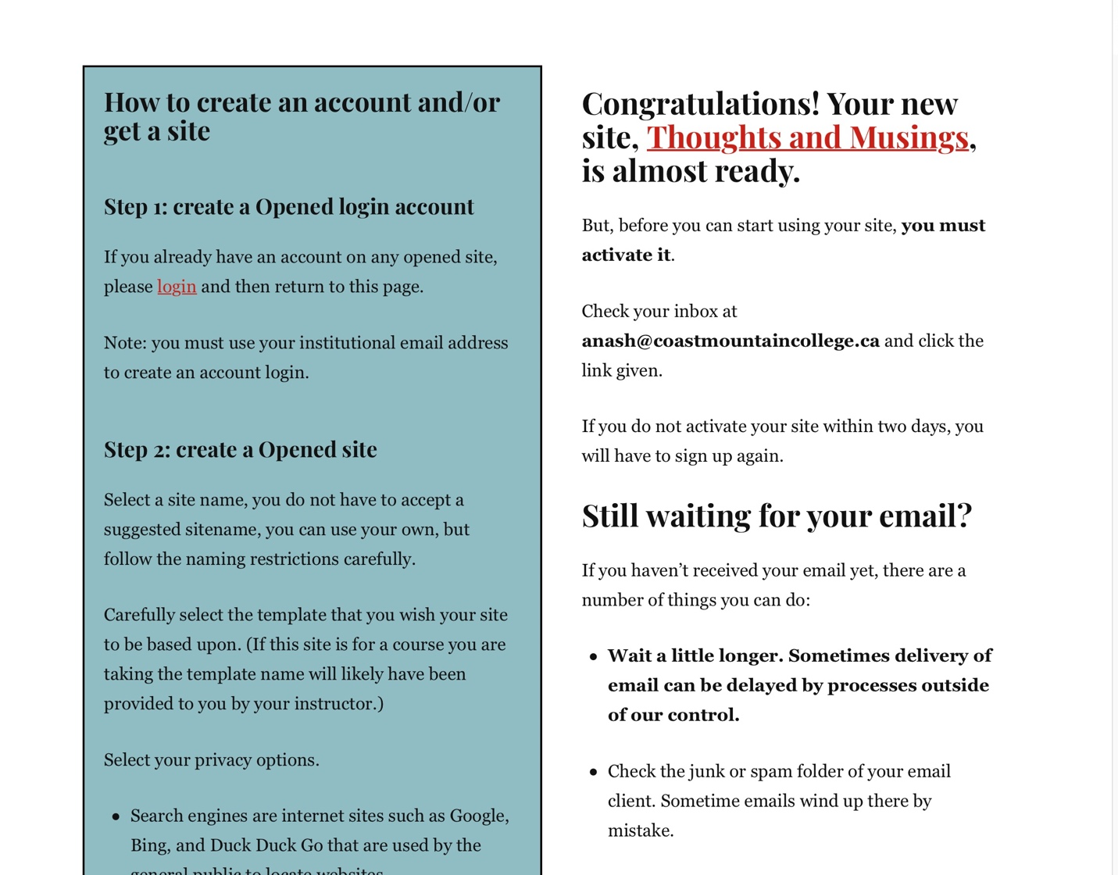

The email will go to your college email address within two days. If you don’t check the email and activate the site within 48 hours you will need to restart this process again.

